**Luke Jacobe D. Magboo**

**FUNDAMENTALS OF DATABASES – WEEK 5 – ACTIVITY 1**

Supply/perform what is asking in the following statements. Create and attach a screenshot for each number to support your answer.Put your screenshot(s) inside your word document to make all the screenshots be uploaded in the STCFlip.

1. Create an ER diagram for a construction company database. Use the following attributes:

a.Employee

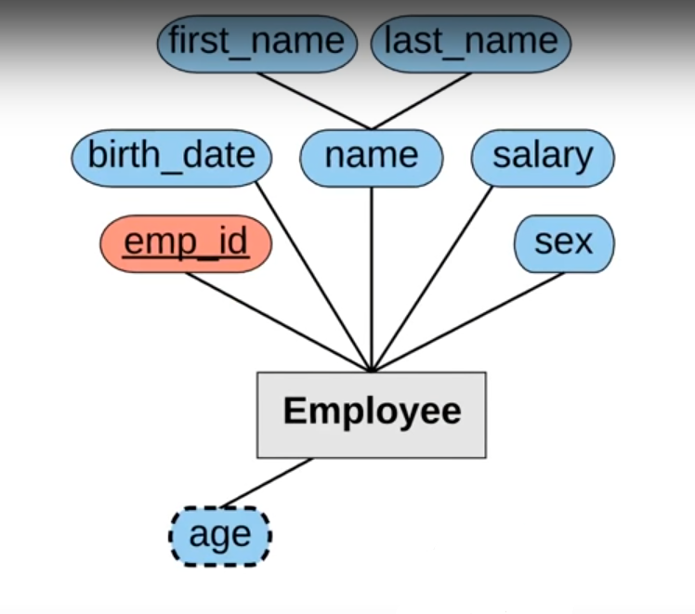

b.Employee_Dependent

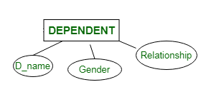

c. Department

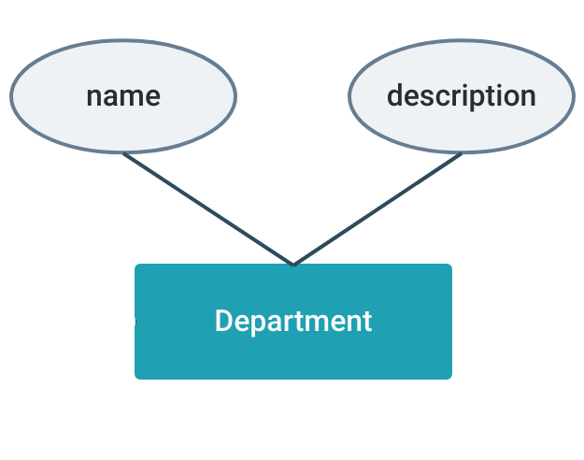

d.Project

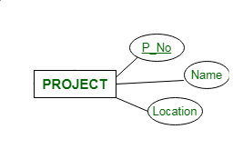

1. In your own words, provide and briefly explain the things to do first or step to create a good schema diagram. (at least 5 modeling steps)
2. So first, we need to go to Schema &gt; New and then we will see a new window will pop up then there is a image that appear after that.
3. Then we need to add new tables into our schema, which we can do by right clicking anywhere on the grid, and selecting the “Table” option.
4. Now we need to add fields to the table. All we have to do is go to Add field, after which a new window will show up. In it you can choose the type, and also set up a few constraints to your new table column:
5. Then we can add relations between tables. We will take the example of creating a many-to-many relation between two tables: Authors and Books. For this, we initially need to create a new table called AuthorBooks, in which we add foreign keys that reference the Authors table and the Books table, respectively:
6. After we are done with that, we should see a schema similar to the following and We can also share the schema with up to five collaborators in the free version.